Data Sheet
Product Information
Product Name | : | Recombinant Human Macrophage-Colony Stimulating Factor (rhM-CSF)
Synonyms | : | Macrophage-colony-stimulating factor 1, MCSF, CSF1
Description | : | Recombinant human M-CSF produced in E. coli is a non-glycosylated 37kDa homodimeric protein containing 159 amino acids polypeptide subunit. M-CSF, also known as CSF-1, is the primary regulator of the survival, proliferation, differentiation and function of mononuclear phagocytes. M-CSF plays important roles in innate immunity, cancer and inflammatory diseases, including systemic lupus erythematosus, arthritis, atherosclerosis and obesity. M-CSF binds to the tyrosine kinase receptor CSF-1 receptor on myeloid progenitor cells, which results in their differentiation into several cell types belonging to the mononuclear phagocyte lineage.
NCBI Accession No. | : | NM_172211.3
Amino acid sequence | : | MEEVSEYCSHMIGSGHLQSLQRLIDSQMETSCQITFEFVDQEQLKDPVCYLK  KAFLLVQDIMEDTMRFRDNTPNAIAIVQLQELSLRLKSCFTKDYEEHDKACV  RTFYETPLQLLEKVKNVFNETKNLLDKDWNIFSKNCNNSFAECSSQGHERQS  EGS
Molecular Mass | : | 18.5 kDa (159 aa)
Protein Tags | : | No tagging
Source | : | E. coli.
Cat. No. | : | JW-H022-0010, JW-H022-0025, JW-H022-0050, JW-H022-0100, JW-H022-0250, JW-H022-0500, JW-H022-1000
Storage | : | Should be at ≤ -70 ℃ as undiluted aliquots of handy size. Avoid repeated freezing and thawing.
Cross Reactivity | : | Monkey, Mouse, Rat

Quality Control
Test items |  |  | Specifications
Appearance |  | : | Clear, colorless liquid
Purity |  | : | Greater than 95 % by SDS-PAGE
Specificity |  | : | Using Western blot, detection | 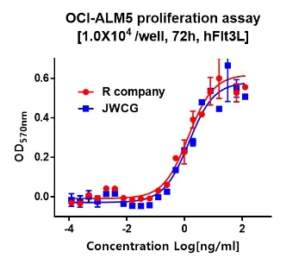
Concentration |  | : | 0.1 mg/㎖, Bradford method
Biological Activity |  | : | Determined by proliferation of M-NFS-60 indicator cells  The ED50 is <1.5 ng/ml, corresponding to a specific activity of > 6.0 × 10⁵ U/mg
Endotoxin |  | : | Less than 0.5 EU/㎍ as determined by the LAL method
Formulation |  | : | PBS w/o NaCl, 5% glycerol (pH 7.4) without preservative or carrier proteins
Stability |  | : | Stable for up to 12 months at -70 ℃. Stable for a month at 4 ℃.
Sterility |  | : | Sterilized through a 0.2 ㎛ membrane filter and packaged aseptically. Culture for 2 weeks, no growth

